**Experiment No: 12**

**Experiment Name:** Implementation of Round-robin Algorithm using C program.

**Aim and Objectives:**

To learn about Round-robin Algorithm and Implement it using a C program

**Code:**

#include<stdio.h>

int main()

{

int count,j,n,time,remain,flag=0,time_quantum;

int wait_time=0,turnaround_time=0,at[10],bt[10],rt[10];

printf("Enter Total Process:\t ");

scanf("%d",&n);

remain=n;

for(count=0;count<n;count++)

{

printf("Enter Arrival Time and Burst Time for Process Process Number %d :",count+1);

scanf("%d",&at[count]);

scanf("%d",&bt[count]);

rt[count]=bt[count];

}

printf("Enter Time Quantum:\t");

scanf("%d",&time_quantum);

printf("\n\nProcess\t|Turnaround Time|Waiting Time\n\n");

for(time=0,count=0;remain!=0;)

{

if(rt[count]<=time_quantum && rt[count]>0)

{

time+=rt[count];

rt[count]=0;

flag=1;

}

else if(rt[count]>0)

{

rt[count]-=time_quantum;

time+=time_quantum;

}

if(rt[count]==0 && flag==1)

{

remain--;

printf("P[%d]\t|\t%d\t|\t%d\n",count+1,time-at[count],time-at[count]-bt[count]);

wait_time+=time-at[count]-bt[count];

turnaround_time+=time-at[count];

flag=0;

}

if(count==n-1)

count=0;

else if(at[count+1]<=time)

count++;

else

count=0;

}

printf("\nAverage Waiting Time= %f\n",wait_time*1.0/n);

printf("Avg Turnaround Time = %f",turnaround_time*1.0/n);

return 0;

}

**Output:**

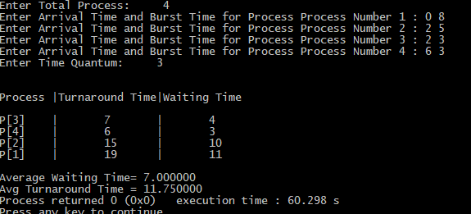

**Conclusion:**

Round-robin is one of the algorithms employed by process and network schedulers in computing. As the term is generally used, time slices (also known as time quanta) are assigned to each process in equal portions and in circular order, handling all processes without priority